Generalization vs Specialization
In normal terms, they both refer to inheritance but the way in which it is implemented or looked into makes the difference. Generalization is the process of extracting shared characteristics from two or more classes, and combining them into a generalized superclass , while specialization means creating new subclasses from an existing class. If it turns out that certain attributes, associations, or methods only apply to some of the objects of the class, a subclass can be created. Both concepts can be implemented using inheritance only. But the order of creation of the subclass and the superclass drives the concept name.
The way or perspective of looking also gives the difference between these two concepts. When you look from the perspective of a base class, it is generalization because the base class has functions or operations that may be commonly used by all of its subclasses. When you look from the perspective of the derived class, it is specialization because even though the common functionalities from the super class are available, the derived classes perform their own operations or functions specific to the purpose of their creation.

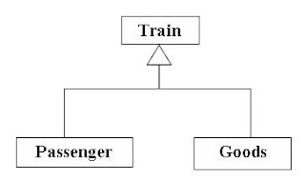

From the above figure, if you see from the perspective of the Train, then it is Generalization. The common functions or operations of both the Passenger and Goods Trains are put into the Train such as startTrain, stopTrain, fillFuel. That is, the generic operations of any subclass of Train are included in Train.

If you see from the perspective of the subclasses (Passenger Train or Goods Train), then it is Specialization. The common functions of the superclass (Train) are also included with the specific functions of the subclass such as boardPassengers, fillWater, fillPantryResources in case of Passenger train and loadGoods, unloadGoods in case of Goods train making the subclass, a class for a specific or special function.

Note: In case of Generalization, it is not necessary that the superclass (Train) should know about the existence of its subclasses (Passenger Train and Goods Train). In case of Specialization, the subclass will always know its superclass.

